### **Project 7：Adjusting Motor Servo Angle**

**Description**

When we make this kit, we often control doors and windows with servos. In this course, we’ll introduce its principle and how to use servo motors. Servo motor is a position control rotary actuator. It mainly consists of housing, circuit board, core-less motor, gear and position sensor. Its working principle is that the servo receives the signal sent by MCU or receiver and produces a reference signal with a period of 20ms and width of 1.5ms, then compares the acquired DC bias voltage to the voltage of the potentiometer and outputs a voltage difference.

Servo motor comes with many specifications. But all of them have three connection wires, distinguished by brown, red, orange colors (different brand may have different color). Brown one is for GND, red one for power positive, orange one for signal line.

The rotation angle of servo motor is controlled by regulating the duty cycle of PWM (Pulse-Width Modulation) signal. The standard cycle of PWM signal is 20ms (50Hz). Theoretically, the width is distributed between 1ms-2ms, but in fact, it's between 0.5ms-2.5ms. The width corresponds the rotation angle from 0° to 180°. But note that for different brand motor, the same signal may have different rotation angle.

[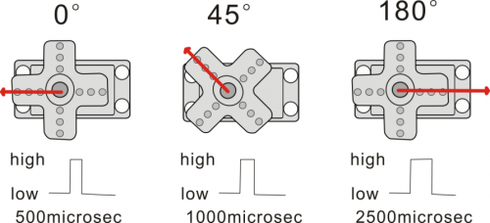](https://wiki.keyestudio.com/File:Ks008536.png)

There are two ways to control a servomotor with Arduino. One is to use a common digital sensor port of Arduino to produce square wave with different duty cycle to simulate PWM signal and use that signal to control the positioning of the motor. Another way is to directly use the Servo function of the Arduino to control the motor. In this way, the program will be easier but it can only control two-contact motor because for the servo function, only digital pin 9 and 10 can be used. The Arduino drive capacity is limited. So if you need to control more than one motor, you will need external power.

**Specifications:**

Working voltage: DC 4.8V ~ 6V Operating angle range: about 180 ° (at 500 → 2500 μsec) Pulse width range: 500 → 2500 μsec No-load speed: 0.12 ± 0.01 sec / 60 (DC 4.8V) 0.1 ± 0.01 sec / 60 (DC 6V) No-load current: 200 ± 20mA (DC 4.8V) 220 ± 20mA (DC 6V) Stopping torque: 1.3 ± 0.01kg · cm (DC 4.8V) 1.5 ± 0.1kg · cm (DC 6V) Stop current: ≦ 850mA (DC 4.8V) ≦ 1000mA (DC 6V) Standby current: 3 ± 1mA (DC 4.8V) 4 ± 1mA (DC 6V) Lead length: 250 ± 5 mm Appearance size: 22.9 * 12.2 * 30mm Weight: 9 ± 1 g (without servo horn) Storage temperature: -20 ℃ ~ 60 ℃ Operating temperature: -10 ℃ ~ 50 ℃

**Experiment equipment：**

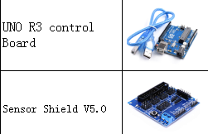

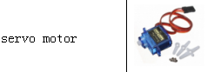

**Connection Diagram：**

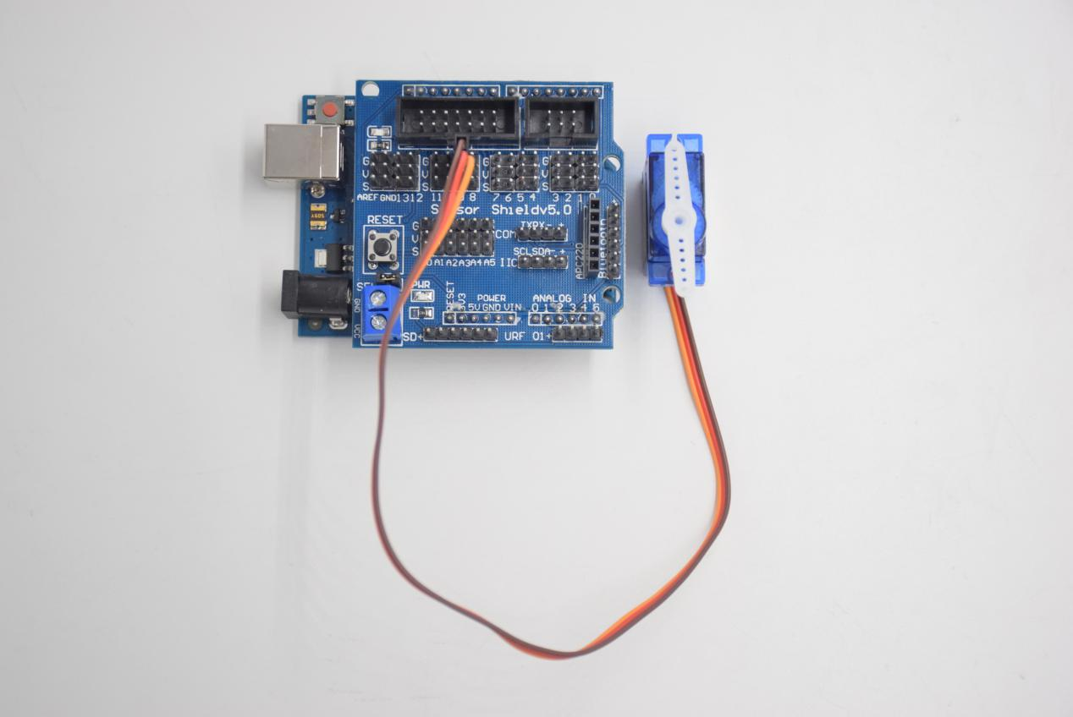

**Steering gear**

**Yellow line -- D9**

**red line -- 5V**

**Brown thread -- GND**

**Test Code：**

**#include <Servo.h> // Servo function library**

**Servo myservo;**

**int pos = 0; // Start angle of servo**

**void setup ()**

**{**

**myservo.attach (9); // Define the position of the servo on D9**

**}**

**void loop ()**

**{**

**for(pos = 0; pos < 180; pos += 1)// angle from 0 to 180 degrees**

**{**

**myservo.write (pos); // The servo angle is pos**

**delay (15); // Delay 15ms**

**}**

**for(pos = 180; pos>=1; pos-=1) // Angle from 180 to 0 degrees**

**{**

**myservo.write (pos); // The angle of the servo is pos**

**delay (15); // Delay 15ms**

**}**

**}**

**Test Result:**

Upload code, wire according to connection diagram, and power on. The servo rotates from 0° to 180° then from 180°~0°